**Integration of RISC-V RV32I Core with UART Communication Using the APB Bus Interface**

**RISC V OUTPUT WAVEFORM:**

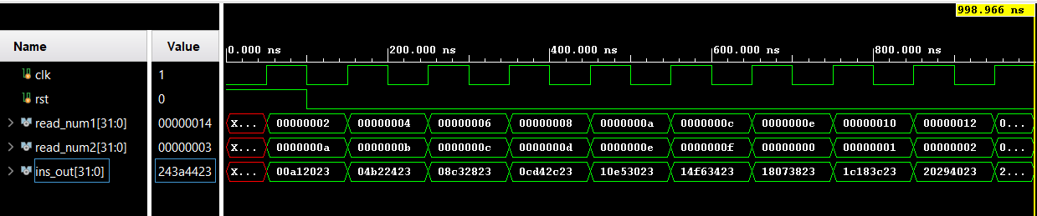

**RISC V WITH UART INTEGRATION OUTPUT WAVEFORM:**

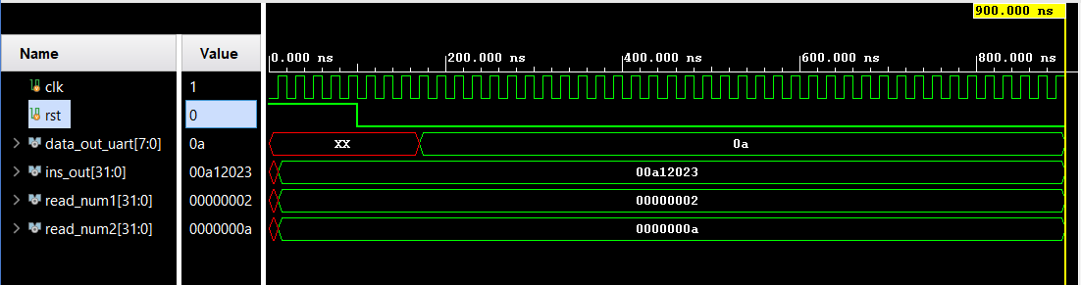

**RISC-V PROCESSOR**

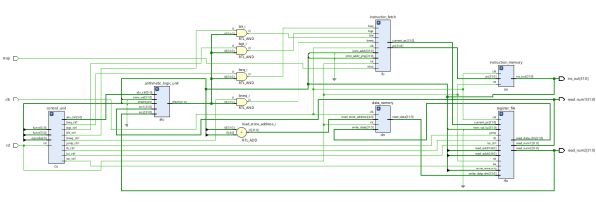

**UART TRANSMITTER & RECEIVER RISC V WITH UART INTEGRATION**

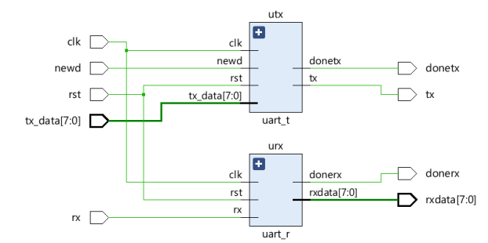 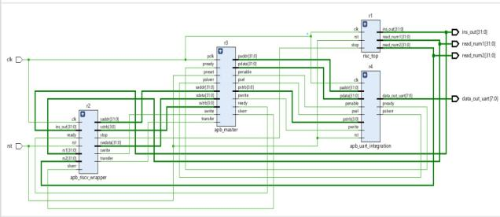

**IMPLEMENTATION ON CHIP POWER**

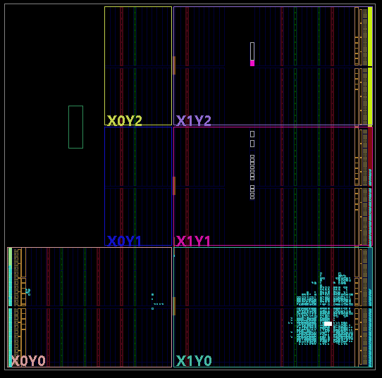 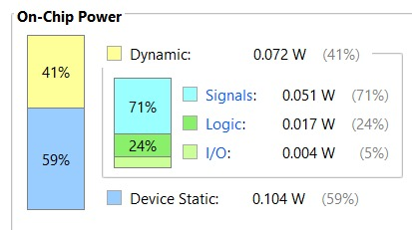

**LUTS USED IN DESIGN**



**DESIGN TIMING SUMMARY**

